Test Report No.: [[TCNo]] Date: [[TCDate3]]

ANNEXURE-[[M08]]
Crushing Test as per Clause 9.2.3

Test Method:

Crush One extinguisher perpendicularly its longitudinal axis, and at its midpoint using 25 mm thick mandrels with a radius at their apex of 12.5 mm and width sufficient to extend beyond sides of the extinguisher (ref. fig). Crush the cylinder till the outer diameter reduces to one third of the original outer diameter
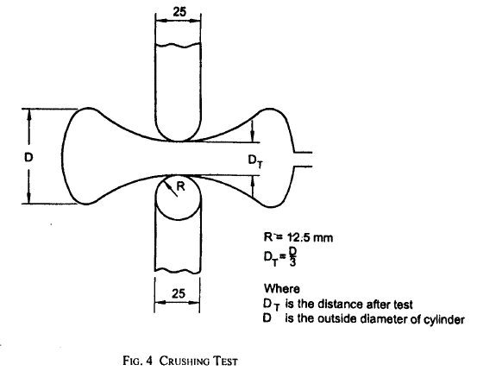
Requirement:

The Extinguishers shall not exhibit any cracks or leaks after subjecting to hydro test at 35 bar.

Observation:

[[ProductDesc]] | [[Cap1]] | [[Cap2]] | [[Cap3]] | [[Cap4]] | [[Cap5]]
Cylinder Sr. Nos. | [[SrNo1_9]] | [[SrNo2_9]] | [[SrNo3_9]] | [[SrNo4_9]] | [[SrNo5_9]]
Cylinders shall not exhibit cracks or leakage | Pass | Pass | Pass | Pass | Pass

