



Date: [[InvoiceDate]]

Manufacturer: Kanex Fire Solutions Limited.

Customer Name: [[Client]]

Warranty Start Date: [[WarrantyStartDate]] Warranty End Date: [[WarrantyEndDate]].

This is to certify that the below extinguishers are warranted for a period of [[WarrantyYear]] year from the date of supply against any of Manufacturing/Quality defects.
NOTE – IF TAMPER SEAL IS NOT INTACT, THE WARRANTY SHALL BE CONSIDERED VOID.

Sr.No. | Type & Capacity of Extinguishers | Quantity | Sr. Nos.
[[SeqNo]] | [[ItemDesc]] | [[Qty]] | [[SrNos]]

Also certify that, all the Fire extinguishers supplied against Invoice No. [[InvoiceNo]] Dated: [[InvoiceDate]] P.O.No. [[PONo]] are hydraulically tested 100% at 35 bar except CO2 and randomly tested for performance test. All the extinguishers confirms to IS 15683:2018 (Portable) or IS 16018:2012 (Mobile) requirements.
Note : If applicable CO2 Cylinders are PESO approved & HPT tested at 225 bar by Cylinder Manufacturer.
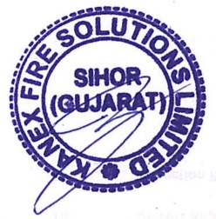
Authorized Signatory
Corp. Off.: Office No.502, 5th Floor, A Wing, Damji Shamji Corporate Square, Ghatkopar -Andheri Link Road, Laxmi Nagar, Ghatkopar (E) Mumbai - 400 075 Tel : +91 022 2500 1288 E-mail : marketing@kanexfire.com
Warranty Certificate
Doc. No: FM-QAC-053 Rev No. 1 Dt. 01.06.2023

